Web Development Unit-3

42. What is Ajax? Explain working of AJAX.

Ans-AJAX = Asynchronous JavaScript and XML. AJAX is a technique for creating fast and dynamic web pages. AJAX allows web pages to be updated asynchronously by exchanging small amounts of data with the server behind the scenes. This means that it is possible to update parts of a web page, without reloading the whole page.

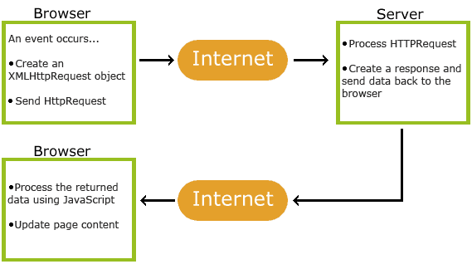

43. Explain Ajax web application model.

Ans-



1. User sends a request from the UI and a javascript call goes to XMLHttpRequest object.
2. HTTP Request is sent to the server by XMLHttpRequest object.
3. Server interacts with the database using JSP, PHP, Servlet, ASP.net etc.
4. Data is retrieved.
5. Server sends XML data or JSON data to the XMLHttpRequest callback function.
6. HTML and CSS data is displayed on the browser.

44. Explain Ajax from developer’s and User’s perspective.

Ans-

45. List and explain properties of XMLHTTPRequest object.

Ans-

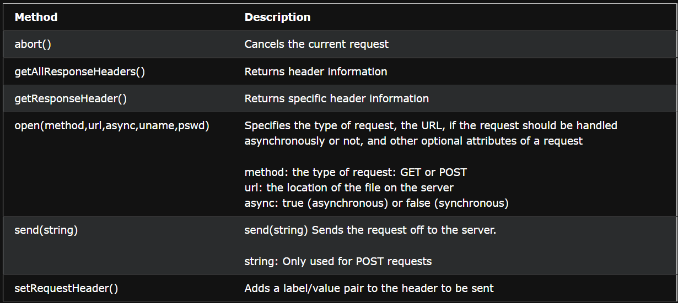

46. List and explain Methods of XMLHTTPRequest object.

Ans-Same as above.

47. What is PHP? Explain different ways to write php code.

Ans-A PHP script can be placed anywhere in the document.

A PHP script starts with <?php and ends with ?>:

<?php

// PHP code goes here

?>

The default file extension for PHP files is ".php".

2A PHP file normally contains HTML tags, and some PHP scripting code.

48. Explain conditional statements in PHP.

Ans-In PHP we have the following conditional statements:

* if statement - executes some code if one condition is true
* if...else statement - executes some code if a condition is true and another code if that condition is false
* if...elseif...else statement - executes different codes for more than two conditions

The if statement executes some code if one condition is true.

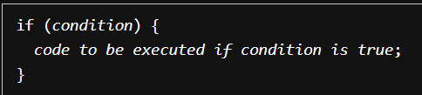

The if...else statement executes some code if a condition is true and another code if that condition is false.

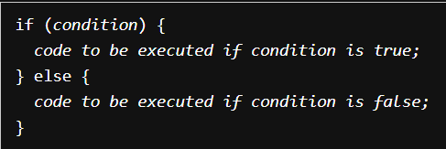

The if...elseif...else statement executes different codes for more than two conditions.

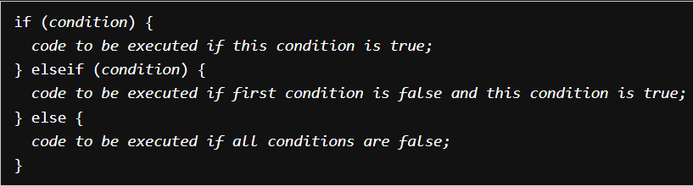

49. Explain looping statements in PHP.

Ans-Loops are used to execute the same block of code again and again, as long as a certain condition is true.

* for - loops through a block of code a specified number of times
* while - loops through a block of code as long as the specified condition is true
* do...while - loops through a block of code once, and then repeats the loop as long as the specified condition is true

The for loop is used when you know in advance how many times the script should run.

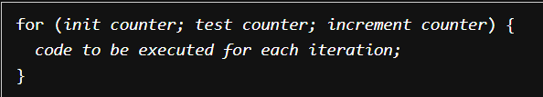

The while loop executes a block of code as long as the specified condition is true.

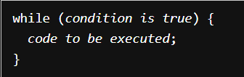

The do...while loop will always execute the block of code once, it will then check the condition, and repeat the loop while the specified condition is true.

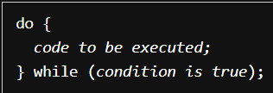

50. Explain Variables in PHP.

Ans- A variable can have a short name (like x and y) or a more descriptive name (age, carname, total_volume).

Rules for PHP variables:

A variable starts with the $ sign, followed by the name of the variable

A variable name must start with a letter or the underscore character

A variable name cannot start with a number

A variable name can only contain alpha-numeric characters and underscores (A-z, 0-9, and _ )

Variable names are case-sensitive ($age and $AGE are two different variables)

51. Explain functions in PHP.

Ans- PHP User Defined Functions

Besides the built-in PHP functions, it is possible to create your own functions.

* A function is a block of statements that can be used repeatedly in a program.
* A function will not execute automatically when a page loads.
* A function will be executed by a call to the function.

52. Explain operators in PHP.

Ans- PHP Operators

Operators are used to perform operations on variables and values.

* Arithmetic operators- The PHP arithmetic operators are used with numeric values to perform common arithmetical operations, such as addition, subtraction, multiplication etc.
* Assignment operators- The PHP assignment operators are used with numeric values to write a value to a variable.
* Comparison operators- The PHP comparison operators are used to compare two values (number or string):
* Increment/Decrement operators- The PHP increment operators are used to increment a variable's value.
* The PHP decrement operators are used to decrement a variable's value.
* Logical operators- The PHP logical operators are used to combine conditional statements.
* String operators- PHP has two operators that are specially designed for strings.
* Array operators- The PHP array operators are used to compare arrays.
* Conditional assignment operators- The PHP conditional assignment operators are used to set a value depending on conditions:

53. Explain arrays in PHP.

Ans- Arrays in PHP is a type of data structure that allows us to store multiple elements of similar data type under a single variable thereby saving us the effort of creating a different variable for every data.

In PHP, there are three types of arrays:

1. Indexed arrays - Arrays with a numeric index
2. Associative arrays - Arrays with named keys
3. Multidimensional arrays - Arrays containing one or more arrays

54. Explain types of arrays used to fetch data from HTML form.

Ans-

55. Explain how to fetch data from html form with PHP.

56. Explain PHP string functions.

Ans- The PHP string functions are part of the PHP core. No installation is required to use these functions.

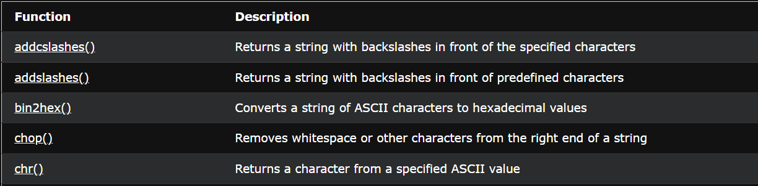

57. Explain PHP control statements like break and goto with example.

58. Explain echo statement used in php.

59. Explain advantages and disadvantages of php.

Ans- Advantages of PHP :

1. It is platform-independent. PHP-based applications can run on any OS like UNIX, Linux, Windows, etc.
2. It is more stable for a few years with the assistance of providing continuous support to various versions.
3. It helps in reusing an equivalent code and not got have to write lengthy code and sophisticated structure for events of web applications.
4. It helps in managing code easily.
5. It has powerful library support to use various function modules for data representation.

Disadvantages of PHP :

1. It is not that secure due to its open-source, because the ASCII text file is often easily available.
2. It is not suitable for giant content-based web applications.
3. It has a weak type, which can cause incorrect data and knowledge to users.
4. PHP frameworks got to learn to use PHP built-in functionalities to avoid writing additional code.
5. Using more features of PHP framework and tools cause poor performance of online applications.

60. Explain how to display php information.